ZNITI_VBRK ---PACKAGE NAME
1-QUS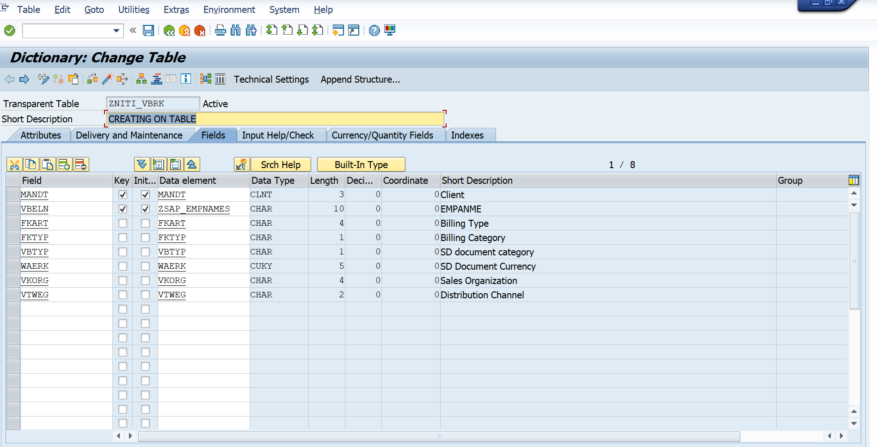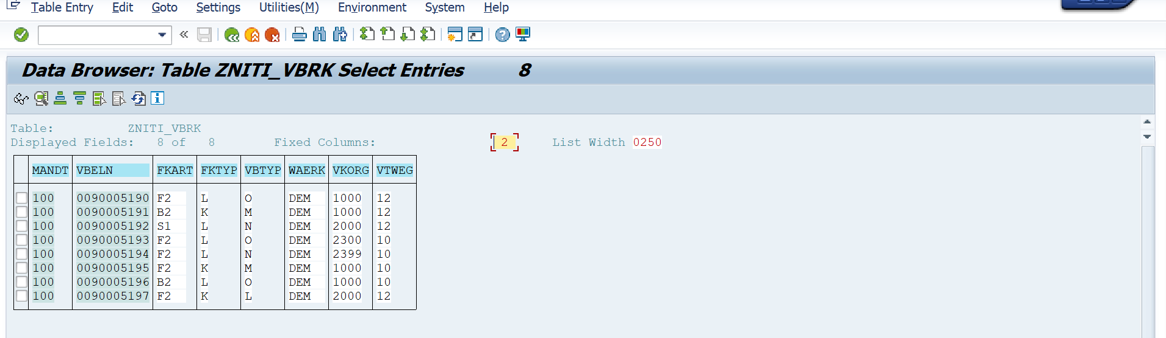
2-QUS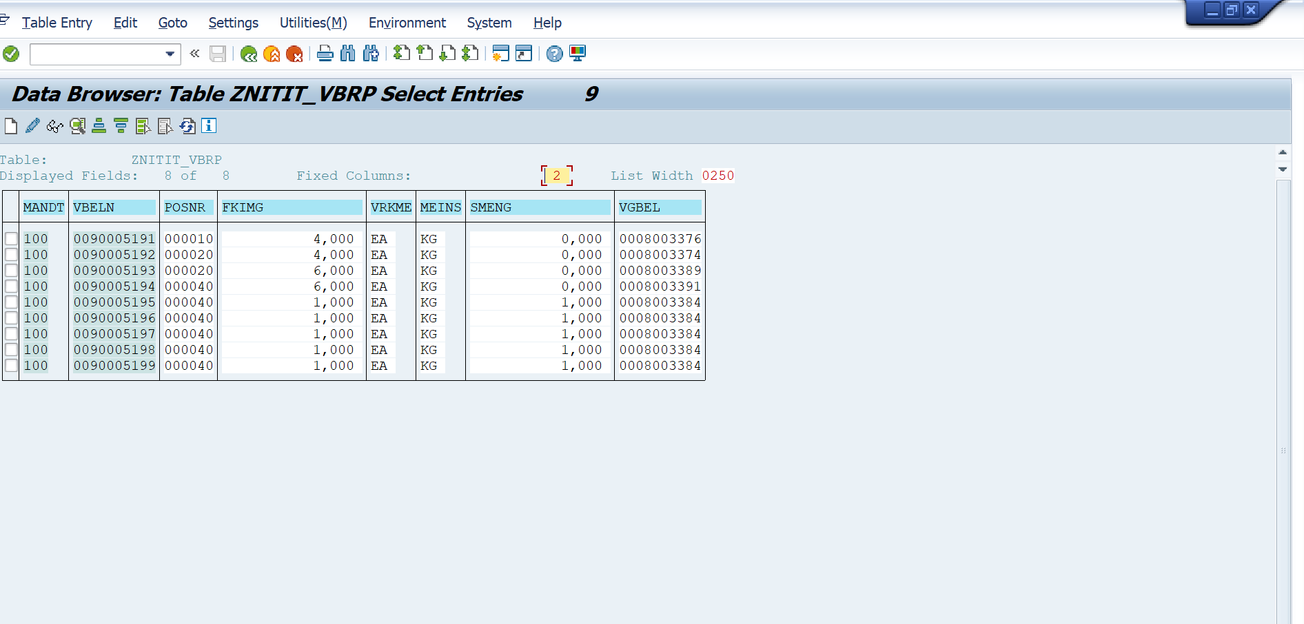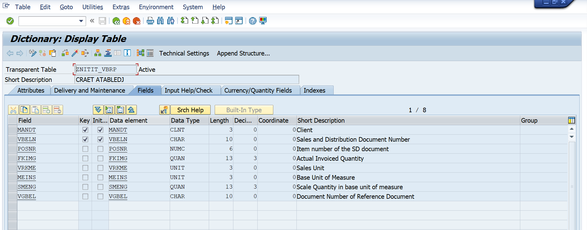
3-QUS
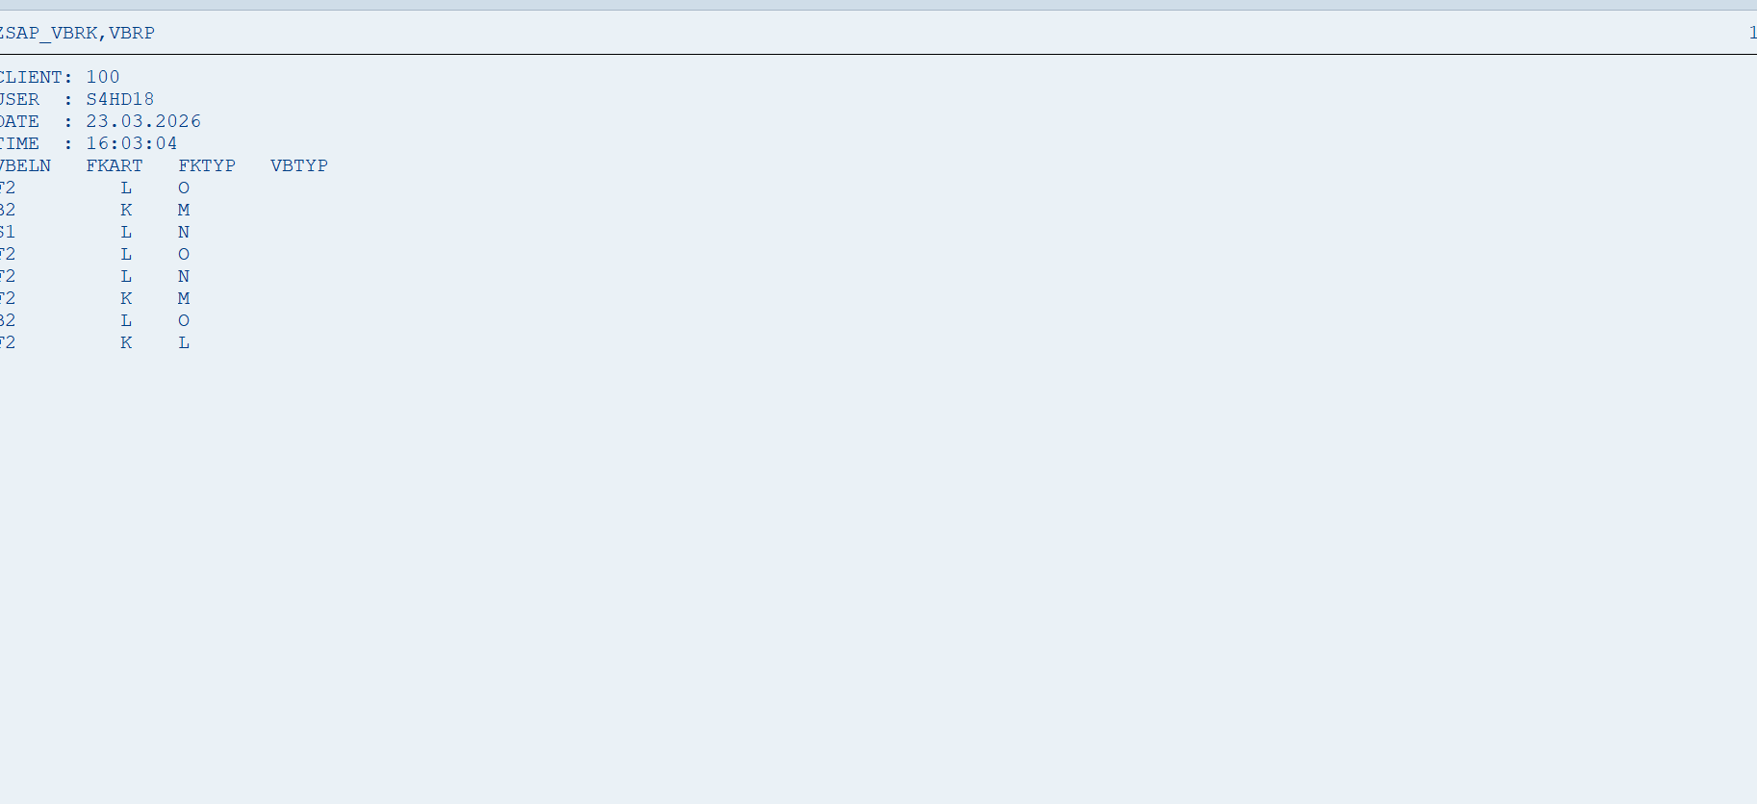REPORT ZNR_PROGRAM1.
TABLES: zniti_vbrk, znitit_vbrp.
DATA: it_vbrk TYPE TABLE OF zniti_vbrk,
wa_vbrk TYPE zniti_vbrk.
DATA: it_vbrp TYPE TABLE OF znitit_vbrp,
wa_vbrp TYPE znitit_vbrp.
DATA: lv_vbeln TYPE zniti_vbrk-vbeln.
SELECT-OPTIONS: s_vbeln FOR zniti_vbrk-vbeln.
START-OF-SELECTION.
SELECT vbeln fkart fktyp vbtyp
INTO TABLE it_vbrk
FROM zniti_vbrk
WHERE vbeln IN s_vbeln.
END-OF-SELECTION.
WRITE: / 'CLIENT:', sy-mandt,
/ 'USER :', sy-uname,
/ 'DATE :', sy-datum,
/ 'TIME :', sy-uzeit.
WRITE: / 'VBELN FKART FKTYP'.
LOOP AT it_vbrk INTO wa_vbrk.
WRITE: / wa_vbrk-vbeln,
wa_vbrk-fkart,
wa_vbrk-fktyp.
HIDE wa_vbrk-vbeln. "Important for drill-down
ENDLOOP.
*AT LINE-SELECTION.
*
* READ CURRENT LINE FIELD VALUE lv_vbeln.
*
* IF lv_vbeln IS NOT INITIAL.
* PERFORM get_item_data USING lv_vbeln.
* ENDIF.
*
*FORM get_item_data USING p_vbeln TYPE zniti_vbrk-vbeln.
*
* CLEAR it_vbrp.
*
* SELECT vbeln posnr fkimg vrkme vgbel meins
* INTO CORRESPONDING FIELDS OF TABLE it_vbrp
* FROM znitit_vbrp
* WHERE vbeln = p_vbeln.
*
* WRITE: / 'ITEM DETAILS FOR:', p_vbeln.
* WRITE: / 'POSNR FKIMG VRKME VGBEL MEINS'.
*
* LOOP AT it_vbrp INTO wa_vbrp.
* WRITE: / wa_vbrp-posnr,
* wa_vbrp-fkimg,
* wa_vbrp-vrkme,
* wa_vbrp-vgbel,
* wa_vbrp-meins.
* ENDLOOP.
*
*ENDFORM.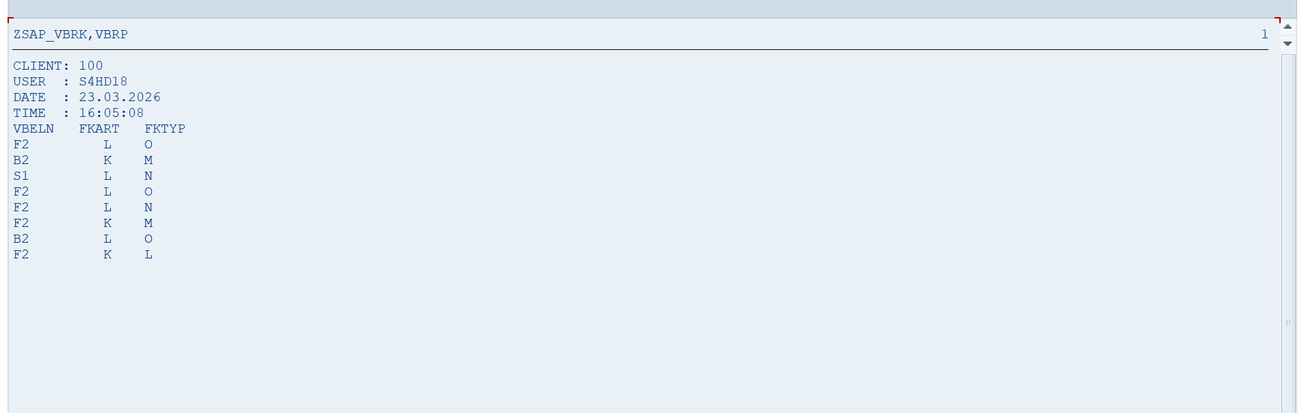
4-QUS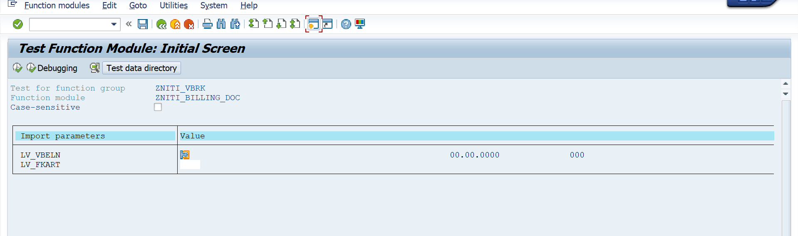FUNCTION zniti_billing_doc.
*"----------------------------------------------------------------------
*"*"Local Interface:
*" IMPORTING
*" REFERENCE(LV_VBELN) TYPE VBRK
*" REFERENCE(LV_FKART) TYPE FKART
*" EXPORTING
*" REFERENCE(ET_VBRK) TYPE ZNITI_VBRK
*" EXCEPTIONS
*" NODATAINEXCEPTION
*"----------------------------------------------------------------------
FUNCTION zniti_billing_doc.
SELECT vbeln
fkdat
fkart
kunrg
netwr
INTO TABLE et_vbrk
FROM vbrk
WHERE vbeln = iv_vbeln
AND fkart = iv_fkart.
IF et_vbrk IS INITIAL.
RAISE no_data_found.
ENDIF.
ENDFUNCTION.

SE38 PROGRAM

*&---------------------------------------------------------------------*
*& Report ZNR_NITI_BILLING_DOC
*&---------------------------------------------------------------------*
*&
*&---------------------------------------------------------------------*
REPORT ZNR_NITI_BILLING_DOC.
PARAMETERS: p_vbeln TYPE vbrk-vbeln,
p_fkart TYPE vbrk-fkart.
DATA: it_vbrk TYPE TABLE OF vbrk,
wa_vbrk TYPE vbrk.
CALL FUNCTION 'ZNITI_BILLING_DOC'
EXPORTING
iv_vbeln = p_vbeln
iv_fkart = p_fkart
TABLES
et_vbrk = it_vbrk
EXCEPTIONS
no_data_found = 1
OTHERS = 2.
IF sy-subrc <> 0.
WRITE: 'No Billing Data Found'.
EXIT.
ENDIF.
LOOP AT it_vbrk INTO wa_vbrk.
WRITE: / 'Billing No:', wa_vbrk-vbeln,
'Date:', wa_vbrk-fkdat,
'Type:', wa_vbrk-fkart,
'Customer:', wa_vbrk-kunrg,
'Amount:', wa_vbrk-netwr.
ENDLOOP.
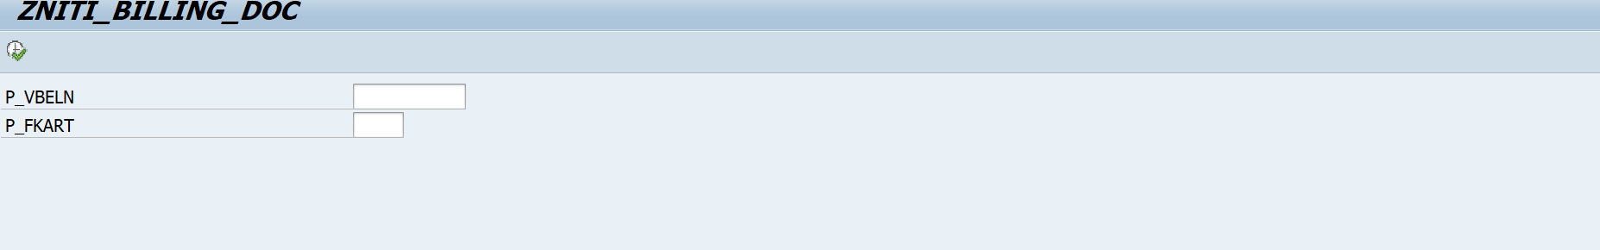

5-QUS

